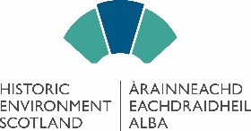
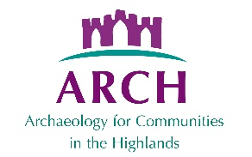
Digitising Highland Maps and Plans
Project Officer
Job Description and Further Information

Post: Project Officer

About the Project:
This project will focus on scanning maps relating to the Highlands. There are a large number of historic maps held in private collections in the Highlands, as well as many in local museums. With a few major exceptions, such as the Sutherland Estate and Lovat Estate, these are not available digitally or to the public. ARCH has hired an A0 flat bed scanner, and volunteers will scan maps from private collections 17-28 August 2026 at the Highland Archive Centre. Owners will drop off and collect maps. This project is part funded by Historic Environment Scotland.
Duration: 16 days to comprise: 14 August (training on use of scanner), 17-21 August, 24-28 August, five additional days before and after this period, as agreed with ARCH Board

Salary: £4000. The successful candidate will be self-employed and responsible for their own tax and NI

Line Manager: Nominated ARCH Trustee

Purpose of Post: The successful candidate will oversee the scanning of maps and plans at the Highland Archive Centre. We are seeking an enthusiastic and self-motivated project officer to:
- Supervise volunteers logging in maps and scanning, providing training as needed
- Ensure an organised and detailed logging system of all maps coming into the system, noted their condition, and logging all movements
- Ensure all paperwork with owners is undertaken
- Ensure robust naming and labelling of all digital files, and that daily backups of work are undertaken
The candidate will have excellent organisational skills, and will be required to do a substantial amount of administration and monitoring.
How to apply: Please provide a full CV and cover letter detailing how you meet the essential, and any desirable, characteristics. This should be sent by e-mail to archhighland@googlemail.com by end of Friday 26th June.
Digitising Highland Maps and Plans
Person Specification

Essential Characteristics
- Demonstrated organisational skills
- Demonstrated time management skills
- Demonstrated ability to train, enthuse and manage volunteers
- Excellent IT skills, particularly ensuring files are named and stored logically
- Good personable skills when dealing with owners
- Basic knowledge of handling old maps and their care

Desirable Characteristics
- Love of old maps
- Knowledge of Highland estates and museums
- Full driving license

About the Map Scanning Project
The information that has been sent to local landowners and museums, inviting them to contact us, can be found our website in the Projects section.

About ARCH:
ARCH was established in 2009 to provide a broad spectrum of activities encouraging people to learn about, participate in and preserve their local heritage. ARCH does this by providing courses (indoors and out), workshops, events, walks, digs, school visits, lectures, surveys, festivals, a website and Facebook with information and links, and other activities which promote heritage in the Highlands. All activities are as accessible as possible, both in terms of physical access and cost, and are open to all regardless of previous past experience. Further information about the organisation and projects can be found on our website: www.archhighland.org.uk

